**Sprint Backlog 03 And Final**

Abdulrahman M Al-Mayouf ID 202002524

Ahmad A Alasadi ID 201502903

Naif O Alotaibi ID 201900636

Abdulrahman Bubshait ID 201900495

Faisal O Alotaibi ID 201601173

Instructor: Dr. David Pumphrey, Ph.D.

ASSE 4311: Learning Outcome Assessment III

4 / 27 / 2024

Contents

**Use Cases** 3

**UC1: Create Date Slots** 5

**UC2: Establish Time Slots** 7

**UC3: Set Maximum Capacity for Time Slots** 9

**UC4 : Choose a Date and Time for Book Pickup** 11

**UC5: View Time Slot Availability** 13

**UC6: Login/Authentication** 15

**UC7: View Schedule** 17

**UC8: Modify or Cancel Time Slots** 19

**UC9: Confirm Booking** 21

**UC10: Allocate Specific Slots Based on Major** 23

**UC11: Automate Pickup Schedule Records** 25

**UC12: Notification on Schedule Changes** 27

**UC13: Update or Cancel Time Slots (Expanded)** 29

**UC14: Edit or Delete Scheduled Pickup Time** 31

**Class Diagram** 33

**Domain model** 33

**ERD** 34

**Data Flow Diagram** 35

**system sequence diagrams (Admin)** 35

**system sequence diagrams (Student)** 36

# **Use Cases**

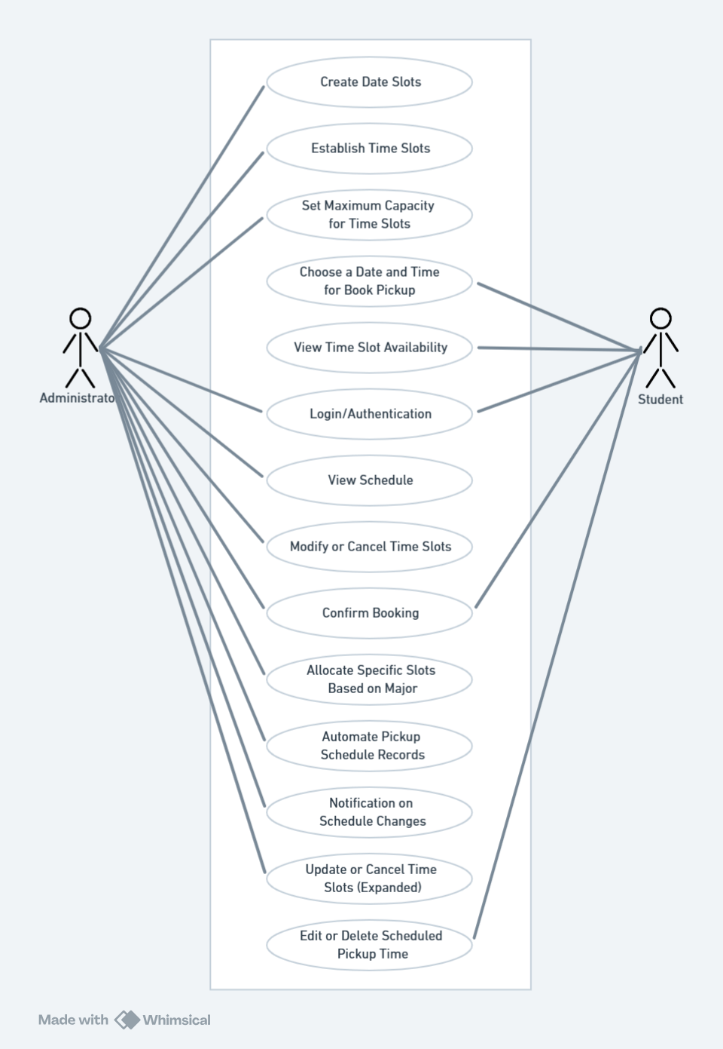

|  |  |  |
| --- | --- | --- |
| Use Case Name | Primary Actor | Goal Description |
| Create Date Slots | Administrator | To create available dates for book pickups. |
| Establish Time Slots | Administrator | To establish specific time intervals within each date for pickups. |
| Set Maximum Capacity for Time Slots | Administrator | To limit the number of pickups in each time slot. |
| Choose a Date and Time for Book Pickup | Student | To select a convenient pickup time. |
| View Time Slot Availability | Student | To see which time slots are available or full. |
| Login/Authentication | Administrator, Student | To securely access the system. |
| View Schedule | Administrator | To view the entire schedule of bookings. |
| Modify or Cancel Time Slots | Administrator | To adjust or cancel existing time slots. |
| Confirm Booking | Student | To confirm the booking of a time slot and receive confirmation. |
| Allocate Specific Slots Based on Major | Administrator | Allocate time slots specifically for students based on their major. |
| Automate Pickup Schedule Records | Administrator | Ensure student pickup times are automatically recorded in the database for accurate record management. |
| Notification on Schedule Changes | Administrator | Receive notifications for any student-initiated edits or cancellations of bookings. |
| Update or Cancel Time Slots (Expanded) | Administrator | Have the flexibility to adjust time slots due to changes in staff availability or bookstore capacity. |
| Edit or Delete Scheduled Pickup Time | Student | Provide flexibility for students to adjust their pickup times as needed before preparation |

.

## **UC1: Create Date Slots**

* **Use Case Title**: Create Date Slots
* **ID**: UC1
* **Scope**: Book Pickup Scheduling System
* **Priority**: High
* **Primary Actor**: Administrator
* **Stakeholders and Interests**:
  + **Administrator**: Wants to efficiently manage the academic calendar by scheduling book pickups.
  + **Students**: Depend on a clear and organized schedule for picking up books.
* **Preconditions**: The administrator is logged into the system with sufficient privileges.
* **Postconditions**: New date slots are created and available for time slot assignment.
* **Main Success Scenario**:
  + The administrator logs into the system.
  + The administrator navigates to the scheduling section.
  + The system presents an option to create a new date slot.
  + The administrator selects the option to create a new date slot.
  + The system displays a form to enter the date.
  + The administrator enters the date and submits the form.
  + The system validates the date and confirms the creation of the new date slot.
* **Extensions**:
  + 6a. If the entered date is invalid or a duplicate:
    1. The system displays an error message.
    2. The administrator is asked to enter a valid date.
* **Special Requirements**: The system must prevent the creation of duplicate date slots.
* **Technology and Data Variations List**: The interface should be accessible via web and mobile platforms.
* **Frequency of Occurrence**: Varies based on the academic calendar and specific scheduling needs.
* **Miscellaneous**: The system should provide a calendar view for easy date selection and visual verification of the scheduling.

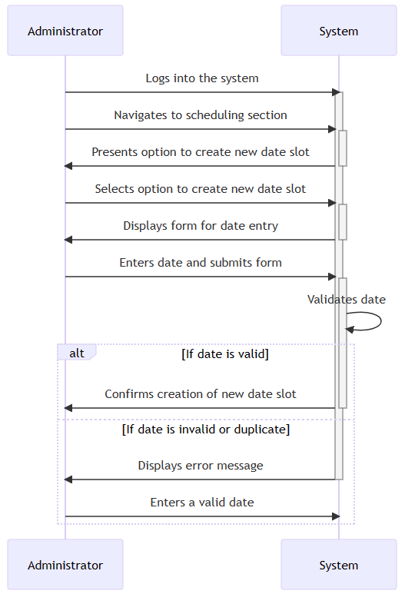

## **UC2: Establish Time Slots**

* **Use Case Title**: Establish Time Slots
* **ID**: UC2
* **Scope**: Book Pickup Scheduling System
* **Priority**: High
* **Primary Actor**: Administrator
* **Stakeholders and Interests**:
  + **Administrator**: Needs to effectively manage the daily flow of students by scheduling specific time slots.
  + **Students**: Require knowledge of available time slots to plan their book pickups.
* **Preconditions**: The administrator has already created date slots.
* **Postconditions**: Time slots are established and available for students to book.
* **Main Success Scenario**:
  + Administrator selects a date slot.
  + Administrator chooses to add a new time slot for that date.
  + A form is presented to define the start and end time of the new slot.
  + Administrator enters the details and sets a maximum capacity.
  + The system validates and saves the new time slot.
* **Extensions**:
  + 4a. If the time slot overlaps with existing ones:
    1. The system alerts the administrator.
    2. Administrator adjusts the time slot accordingly.
* **Special Requirements**: Time slots should not overlap for the same date.
* **Technology and Data Variations List**: Should support adjustments via both web and mobile interfaces.
* **Frequency of Occurrence**: Regularly, as needed to adapt to the academic calendar and specific event schedules.
* **Miscellaneous**: Ability to modify or delete time slots after creation is essential.

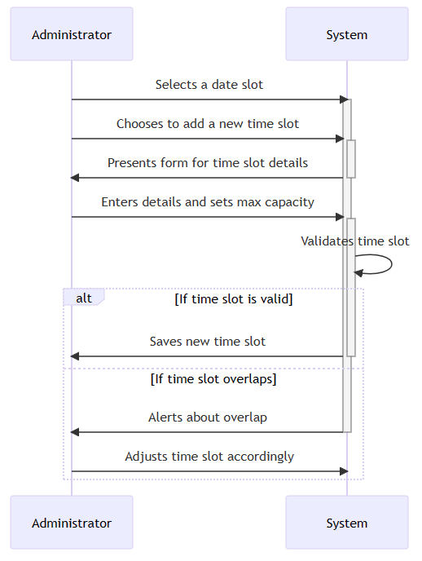

## **UC3: Set Maximum Capacity for Time Slots**

* **Use Case Title**: Set Maximum Capacity for Time Slots
* **ID**: UC3
* **Scope**: Book Pickup Scheduling System
* **Priority**: High
* **Primary Actor**: Administrator
* **Stakeholders and Interests**:
  + **Administrator**: Wants to ensure the bookstore can handle the volume of pickups without overcrowding.
  + **Students**: Need a smooth pickup experience without long wait times.
* **Preconditions**: Time slots have been established for a given date.
* **Postconditions**: Each time slot has a set maximum capacity to manage the number of students.
* **Main Success Scenario**:
  + Administrator selects an existing time slot.
  + Administrator inputs or edits the maximum capacity for that slot.
  + The system saves the updated capacity limit.
* **Extensions**:
  + 2a. If the input capacity exceeds physical or regulatory limits:
    1. The system warns the administrator.
    2. Administrator revises the capacity to an acceptable number.
* **Special Requirements**: The system must dynamically update the remaining slots as students book their pickups.
* **Technology and Data Variations List**: Should be manageable via both desktop and mobile interfaces.
* **Frequency of Occurrence**: As needed, typically at the setup of the academic period or event planning.
* **Miscellaneous**: Considerations for adjusting capacity based on health guidelines or changes in pickup location setup.

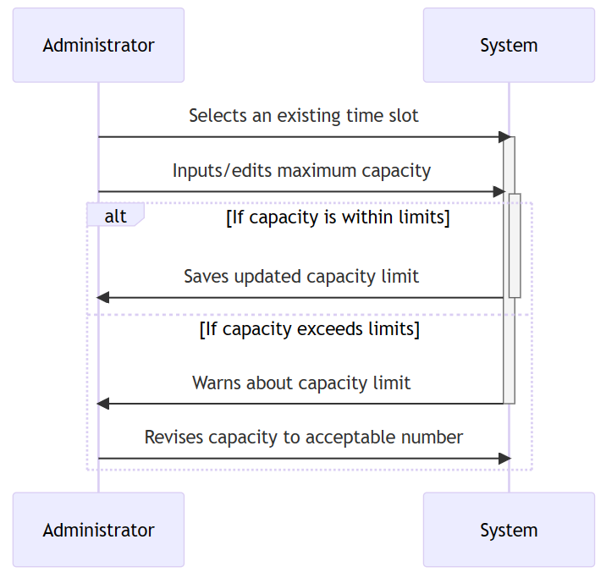

## **UC4 : Choose a Date and Time for Book Pickup**

* **Use Case Title**: Choose a Date and Time for Book Pickup
* **ID**: UC4
* **Scope**: Book Pickup Scheduling System
* **Level**: User Goal
* **Priority**: High
* **Primary Actor**: Student
* **Stakeholders and Interests**:
  + **Student**: Wants an easy and flexible way to schedule a book pickup time that fits their schedule.
  + **Administrator**: Needs to ensure the schedule is adhered to and resources are not overstretched.
* **Preconditions**: The student is registered, logged in, and has books ready for pickup.
* **Postconditions**: The student has successfully scheduled a pickup time.
* **Main Success Scenario (Basic Flow)**:
  + The student logs into the system.
  + The system presents available dates for book pickups.
  + The student selects a preferred date.
  + The system displays available time slots for the selected date.
  + The student selects a preferred time slot.
  + The system confirms the booking and updates the schedule.
* **Extensions (Alternative Flows)**:
  + 4a. If no time slots are available for the selected date:
    1. The system notifies the student of the lack of availability.
    2. The student is prompted to select another date.
  + Any step: System failure or loss of connectivity.
    1. The system logs the error.
    2. The student is notified of the issue and asked to retry later.
* **Special Requirements**: The system must update in real-time to reflect current availability.
* **Technology and Data Variations List**: Mobile and web interfaces should be supported.
* **Frequency of Occurrence**: Potentially multiple times daily during peak periods.
* **Miscellaneous**: Consideration for time zone differences if applicable.

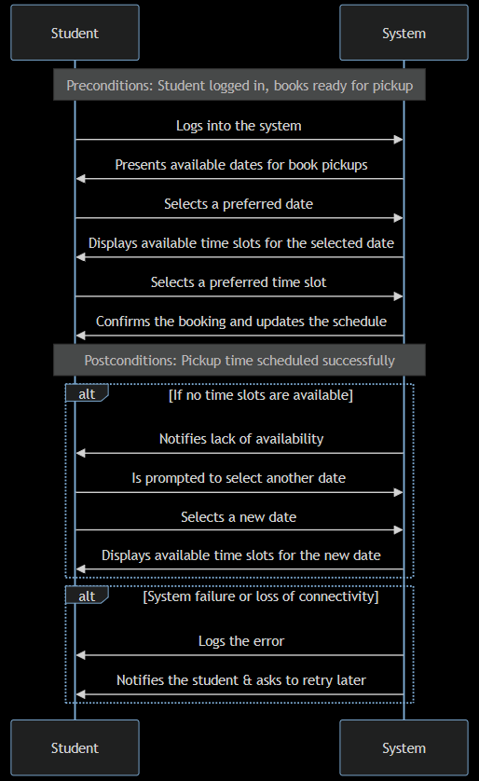

## **UC5: View Time Slot Availability**

* **Use Case Title**: View Time Slot Availability
* **ID**: UC5
* **Scope**: Book Pickup Scheduling System
* **Priority**: High
* **Primary Actor**: Student
* **Stakeholders and Interests**:
  + **Students**: Want to select a time slot that fits their schedule and is not full.
  + **Administrator**: Needs to provide up-to-date information on slot availability to manage student flow efficiently.
* **Preconditions**: Time slots have been established and are visible to students.
* **Postconditions**: The student is informed of available and unavailable time slots.
* **Main Success Scenario**:
  + Student logs in and navigates to the booking section.
  + The system displays available dates.
  + Student selects a date to view available time slots.
  + The system shows time slots with their availability status and remaining capacity.
* **Extensions**:
  + 4a. All slots for a selected date are full:
    1. The system indicates no available slots.
    2. Student may choose another date or be placed on a waitlist.
* **Special Requirements**: Real-time updating of slot availability to reflect current bookings.
* **Technology and Data Variations List**: Accessible on both mobile and web platforms for convenience.
* **Frequency of Occurrence**: Frequently, especially during peak academic periods.
* **Miscellaneous**: The system should highlight overbooked or unavailable slots distinctly.

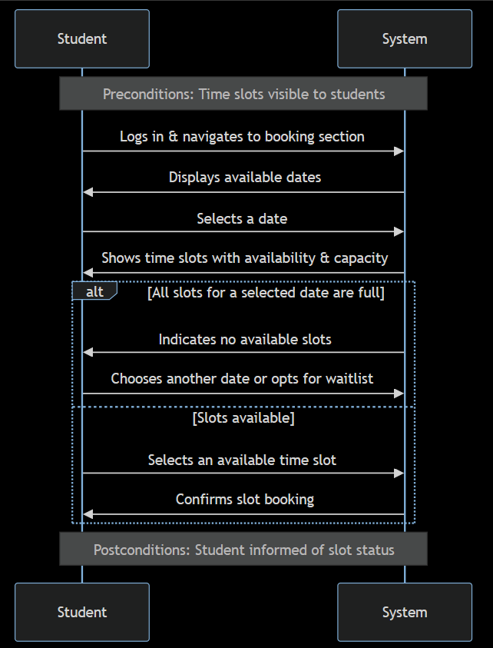

## **UC6: Login/Authentication**

* **Use Case Title**: Login/Authentication
* **ID**: UC6
* **Scope**: Book Pickup Scheduling System
* **Priority**: Essential
* **Primary Actors**: Administrator, Student
* **Stakeholders and Interests**:
  + **Students and Administrators**: Need secure access to their respective functionalities within the system.
* **Preconditions**: User is registered with the system.
* **Postconditions**: User is authenticated and gains access to the system.
* **Main Success Scenario**:
  + User navigates to the login page.
  + User enters their credentials (username and password).
  + The system verifies the credentials against the stored user database.
  + Authentication is successful, and the user is granted access to their dashboard.
* **Extensions**:
  + 3a. If the credentials are incorrect:
    1. The system displays an error message.
    2. User is prompted to try again or reset their password.
* **Special Requirements**: Use of secure protocols for data transmission. Implementation of measures to prevent brute force attacks.
* **Technology and Data Variations List**: The system should support various methods of authentication (e.g., OAuth, two-factor authentication) for enhanced security.
* **Frequency of Occurrence**: Each time a user accesses the system.
* **Miscellaneous**: Consideration for account lockout policies after multiple failed attempts.

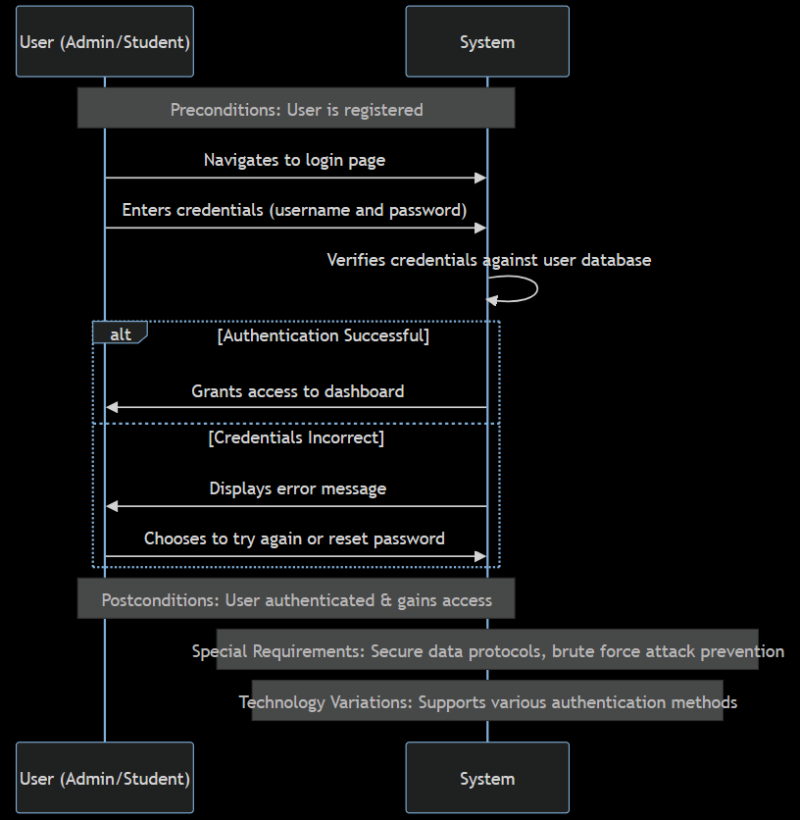

## **UC7: View Schedule**

* **Use Case Title**: View Schedule
* **ID**: UC7
* **Scope**: Book Pickup Scheduling System
* **Priority**: High
* **Primary Actor**: Administrator
* **Stakeholders and Interests**:
  + **Administrator**: Needs a comprehensive overview of the booking schedule to manage and adjust the pickup process efficiently.
  + **Students**: Rely on the administrators to provide a smooth and orderly pickup experience by effectively managing the schedule.
* **Preconditions**: Administrator is logged into the system.
* **Postconditions**: Administrator has an up-to-date view of all bookings.
* **Main Success Scenario**:
  + Administrator accesses the scheduling section of the system.
  + System displays a comprehensive view of the booking schedule, including dates, time slots, and their capacities.
  + Administrator reviews and assesses the schedule for any necessary adjustments.
* **Extensions**:
  + Any step: If adjustments are needed, the administrator can navigate to editing functions directly from the schedule view.
* **Special Requirements**: Real-time updating to reflect changes in bookings or slot adjustments.
* **Technology and Data Variations List**: Should be accessible and clear on both desktop and mobile interfaces.
* **Frequency of Occurrence**: Regularly, as part of daily administrative tasks.
* **Miscellaneous**: Options for exporting or printing the schedule could enhance functionality.

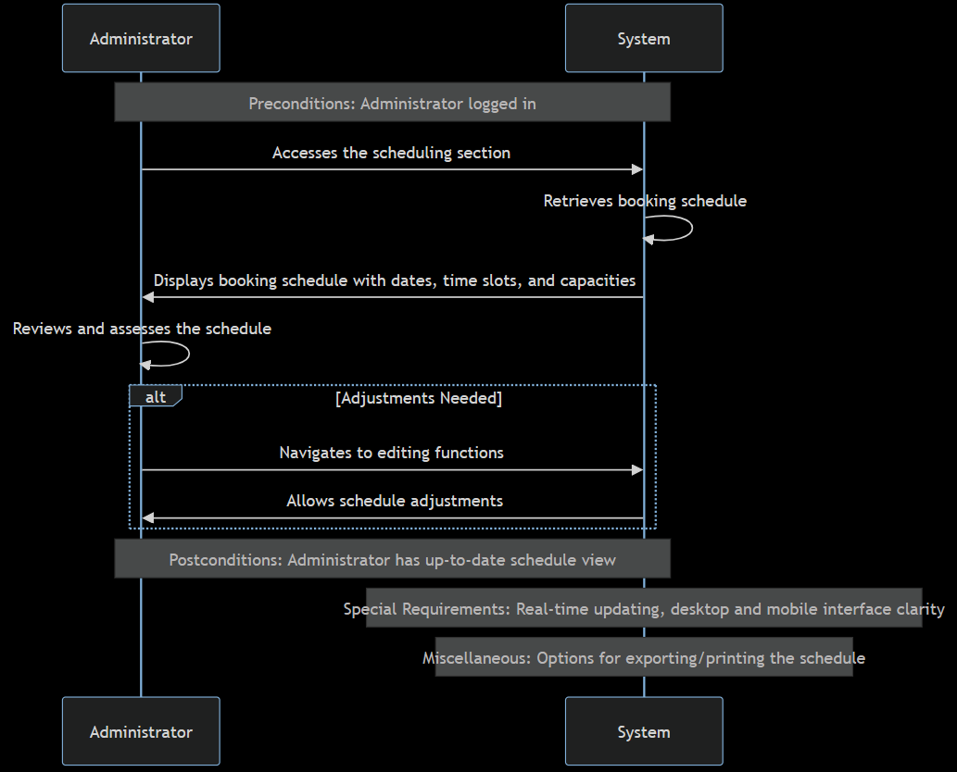

## **UC8: Modify or Cancel Time Slots**

* **Use Case Title**: Modify or Cancel Time Slots
* **ID**: UC8
* **Scope**: Book Pickup Scheduling System
* **Priority**: High
* **Primary Actor**: Administrator
* **Stakeholders and Interests**:
  + **Administrator**: Wants the flexibility to adjust the schedule for optimal operation.
  + **Students**: Need accurate and current information on available pickup times.
* **Preconditions**: Administrator has access to the scheduling system.
* **Postconditions**: Time slots are accurately updated to reflect changes.
* **Main Success Scenario**:
  + Administrator identifies a time slot needing adjustment or cancellation.
  + System provides options to modify details or cancel the slot.
  + Administrator submits the changes or cancels the slot.
  + System updates to reflect the changes immediately.
* **Extensions**:
  + 3a. If modifications conflict with existing bookings:
    1. System alerts the administrator.
    2. Administrator decides on further actions, such as rescheduling bookings.
* **Special Requirements**: Immediate notification to affected students if a booking is canceled or time changed.
* **Technology and Data Variations List**: Access through web and mobile platforms.
* **Frequency of Occurrence**: As needed based on schedule changes or errors.
* **Miscellaneous**: Option for bulk modifications could be useful for large-scale changes.

Top of Form

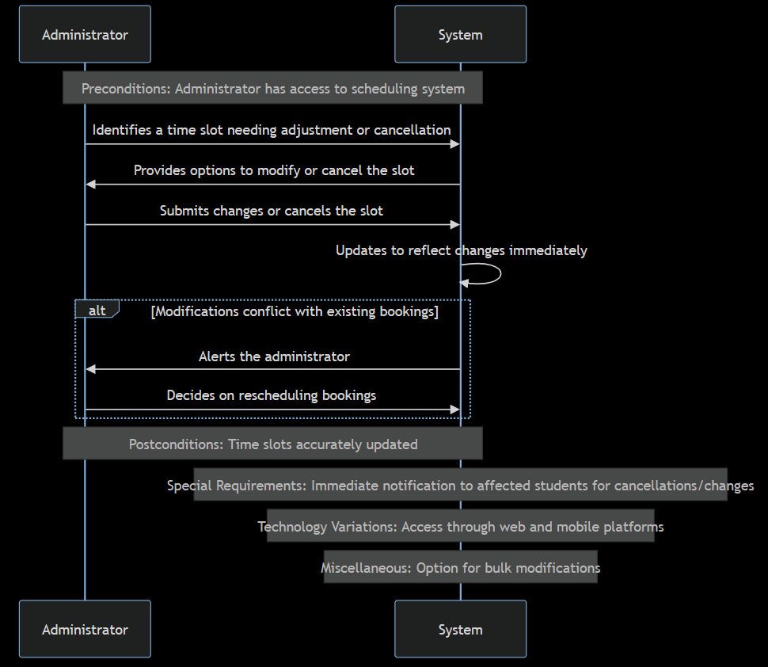

## **UC9: Confirm Booking**

* **Use Case Title**: Confirm Booking
* **ID**: UC9
* **Scope**: Book Pickup Scheduling System
* **Priority**: High
* **Primary Actor**: Student
* **Stakeholders and Interests**:
  + **Students**: Want a confirmed booking for their selected pickup time.
  + **Administrator**: Needs to ensure the booking process is smooth and manageable.
* **Preconditions**: Student has selected a date and time slot.
* **Postconditions**: Booking is confirmed and recorded in the system.
* **Main Success Scenario**:
  + Student reviews their selected time slot and proceeds to confirm.
  + System validates the availability and confirms the booking.
  + Student receives confirmation of their booking.
* **Extensions**:
  + 2a. If the selected time slot becomes unavailable:
    1. System notifies the student.
    2. Student is prompted to select a different time slot.
* **Special Requirements**: System must send an immediate booking confirmation via email or SMS.
* **Technology and Data Variations List**: Accessible on both web and mobile platforms for booking confirmation.
* **Frequency of Occurrence**: Frequently, especially during the start of new academic periods.
* **Miscellaneous**: Consideration for a waitlist system if desired slots are full.

Top of Form

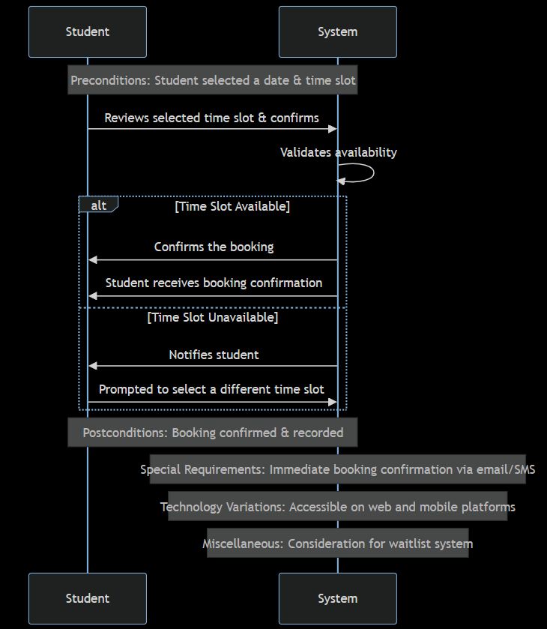

## **UC10: Allocate Specific Slots Based on Major**

* **Use Case Title**: Allocate Specific Slots Based on Major
* **ID**: UC10
* **Scope**: Book Pickup Scheduling System
* **Priority**: High
* **Primary Actor**: Administrator
* **Stakeholders and Interests**:
  + **Students**: Want convenient and efficient access to course-specific materials during pickups.
  + **Administrator**: Seeks to streamline the pickup process according to course material availability and student major.
* **Preconditions**: Administrator has access to student majors and material availability.
* **Postconditions**: Specific slots are allocated and available for students by major.
* **Main Success Scenario**:
  + Administrator identifies material availability by major.
  + System displays a scheduling interface for slot allocation.
  + Administrator allocates slots based on major and material availability.
  + System updates to reflect the specialized slots.
* **Extensions**:
  + 3a. If there is insufficient availability for a major:
    1. System prompts for alternative scheduling.
    2. Administrator adjusts allocations accordingly.
* **Special Requirements**: System must be able to categorize and display slots based on student major.
* **Technology and Data Variations List**: Should accommodate variations in major requirements and material availability.
* **Frequency of Occurrence**: Regularly, at the beginning of each academic term or as new materials become available.
* **Miscellaneous**: May require coordination with academic departments to understand material needs.

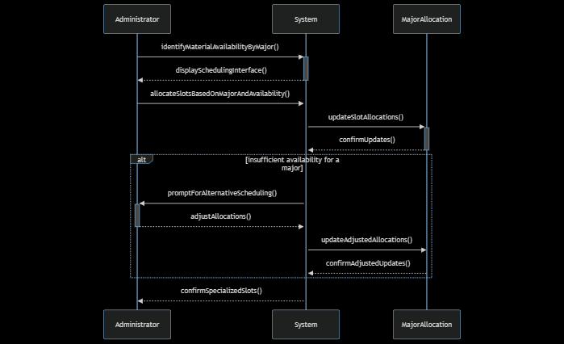

## **UC11: Automate Pickup Schedule Records**

* **Use Case Title**: Automate Pickup Schedule Records
* **ID**: UC11
* **Scope**: Book Pickup Scheduling System
* **Priority**: High
* **Primary Actor**: Administrator
* **Stakeholders and Interests**:
  + **Administrators**: Want an efficient, error-free way to maintain accurate records of student pickup schedules.
  + **Students**: Need their pickup schedules to be accurately recorded and maintained for smooth pickup experiences.
* **Preconditions**: Student has successfully booked a pickup time.
* **Postconditions**: The booking is automatically recorded in the system database.
* **Main Success Scenario**:
  + Student confirms a booking through the system.
  + System automatically adds this booking to the database.
  + Administrator can view and verify the updated records.
* **Extensions**:
  + 2a. In case of a system error during record update:
    1. System logs the error.
    2. Administrator receives a notification for manual intervention.
* **Special Requirements**: System requires reliable database connectivity for real-time updates.
* **Technology and Data Variations List**: System should support both web and mobile interfaces for accessing and managing records.
* **Frequency of Occurrence**: Each time a booking is made or modified.
* **Miscellaneous**: System should have backup and recovery procedures for data integrity.

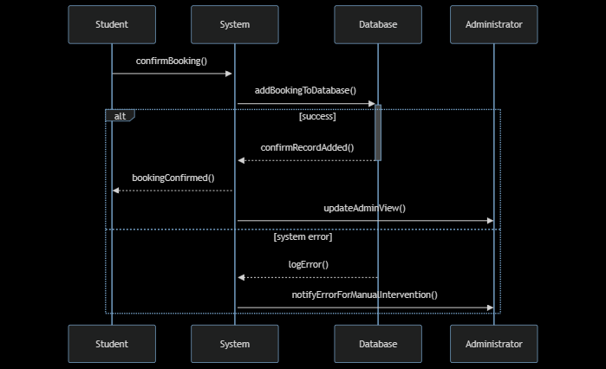

## **UC12: Notification on Schedule Changes**

* **Use Case Title**: Notification on Schedule Changes
* **ID**: UC12
* **Scope**: Book Pickup Scheduling System
* **Priority**: High
* **Primary Actor**: Administrator
* **Stakeholders and Interests**:
  + **Administrators**: Need to stay informed about any changes to maintain an accurate and functional schedule.
  + **Students**: Expect the administration to be aware of their schedule changes to accommodate their needs.
* **Preconditions**: Students have the ability to edit or cancel their bookings.
* **Postconditions**: Administrators are promptly notified of any changes.
* **Main Success Scenario**:
  + Student edits or cancels a booked pickup time.
  + The system automatically generates a notification to the administrator.
  + Administrator receives the notification and adjusts the schedule as necessary.
* **Extensions**:
  + 2a. If the notification fails to send:
    1. System attempts to resend the notification.
    2. If failure persists, system logs the issue for administrator review.
* **Special Requirements**: Reliable notification system for real-time updates.
* **Technology and Data Variations List**: Notifications could be via email, SMS, or system dashboard alerts.
* **Frequency of Occurrence**: As often as students make changes to their bookings.
* **Miscellaneous**: Option for administrators to subscribe to or mute notifications based on their preferences.

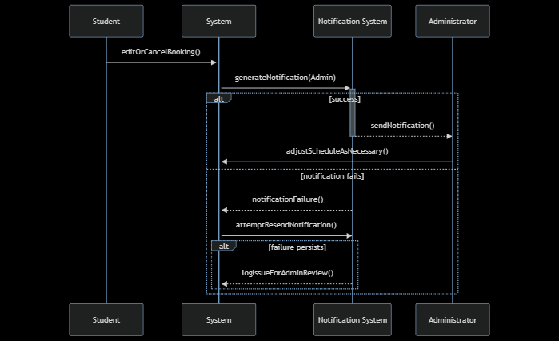

## **UC13: Update or Cancel Time Slots (Expanded)**

* **Use Case Title**: Update or Cancel Time Slots (Expanded)
* **ID**: UC13
* **Scope**: Book Pickup Scheduling System
* **Priority**: High
* **Primary Actor**: Administrator
* **Stakeholders and Interests**:
  + **Administrators**: Need flexibility to adapt the schedule due to unforeseen circumstances.
  + **Students**: Require updated information on time slots for planning their pickups.
* **Preconditions**: Administrator has access to the scheduling interface.
* **Postconditions**: Time slots are updated or canceled as needed, with changes reflected in the system.
* **Main Success Scenario**:
  + Administrator identifies a time slot needing changes.
  + Accesses the scheduling interface to update details or cancel the slot.
  + System processes the changes, updates the schedule, and optionally notifies affected students.
* **Extensions**:
  + 3a. If changes impact existing student bookings:
    1. System automatically notifies students of the change.
    2. Offers alternatives or allows for rebooking.
* **Special Requirements**: System must manage and reflect changes in real-time to prevent booking conflicts.
* **Technology and Data Variations List**: Web and mobile platforms should be supported for making changes.
* **Frequency of Occurrence**: As required by changes in availability or capacity.
* **Miscellaneous**: Consideration for an audit trail of changes for administrative purposes.

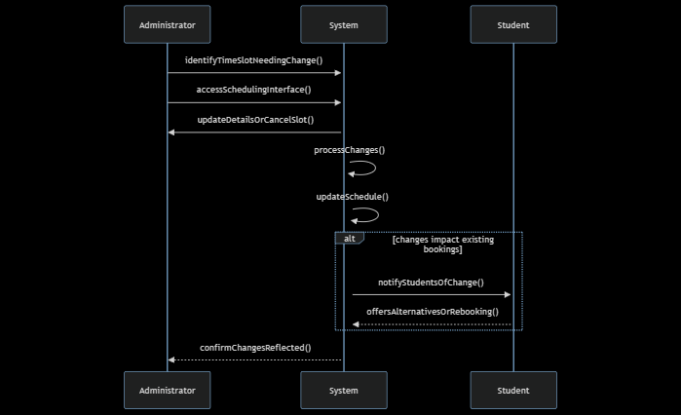

## **UC14: Edit or Delete Scheduled Pickup Time**

* **Use Case Title**: Edit or Delete Scheduled Pickup Time
* **ID**: UC14
* **Scope**: Book Pickup Scheduling System
* **Priority**: High
* **Primary Actor**: Student
* **Stakeholders and Interests**:
  + **Students**: Want the ability to adjust their pickup times to accommodate changes in their schedules.
  + **Administrators**: Must manage and update the schedule based on these changes to maintain order and efficiency.
* **Preconditions**: The student has a scheduled pickup time.
* **Postconditions**: The student’s pickup time is updated or canceled as per their request.
* **Main Success Scenario**:
  + Student logs into the system and navigates to their scheduled bookings.
  + Chooses an existing booking to edit or delete.
  + Submits the changes or cancels the booking.
  + System updates the schedule accordingly.
* **Extensions**:
  + 3a. If editing leads to conflicts or violates booking rules:
    1. System alerts the student and suggests corrections.
* **Special Requirements**: System should provide immediate feedback on availability for rebooking scenarios.
* **Technology and Data Variations List**: Should be seamlessly operational on both desktop and mobile interfaces.
* **Frequency of Occurrence**: Likely to occur frequently, especially during peak academic periods.
* **Miscellaneous**: The system might implement a cut-off time for changes to ensure operational feasibility.

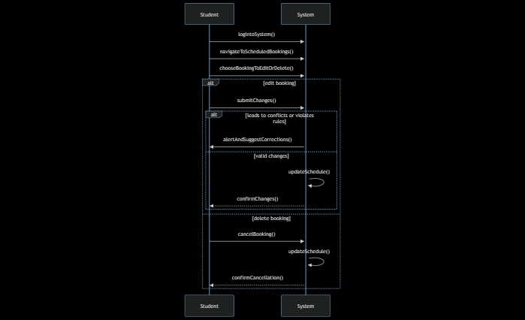

# **Class Diagram**

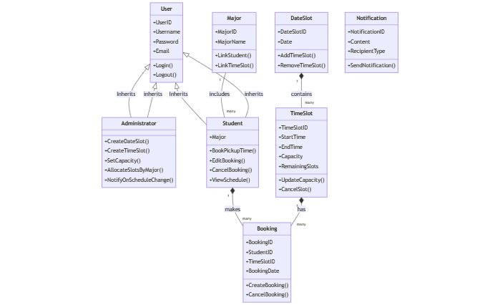

# **Domain model**

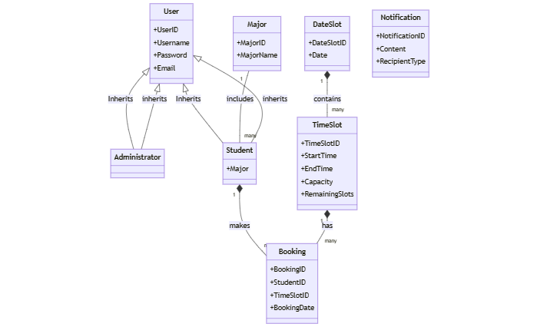

# **ERD**

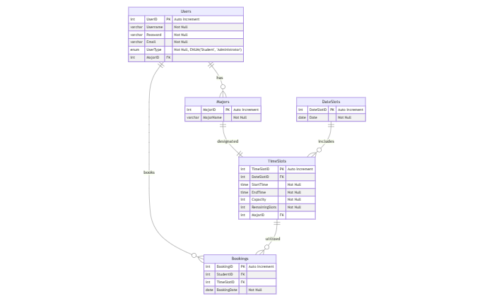

# **Data Flow Diagram**

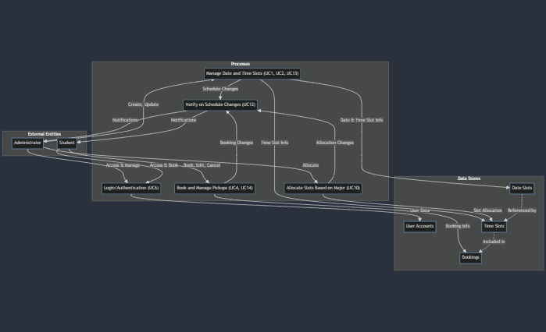

# **system sequence diagrams (Admin)**

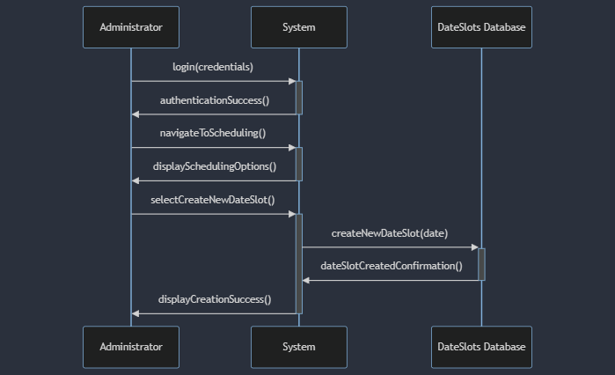

# **system sequence diagrams (Student)**

